CS506 Programming for Computing
HOP06A – Set Up Jupyter Notebooks
06/06/2020 Created by Apiwat Chuaphan
11/08/2020 Revised by Kim Nguyen
Center for Information Assurance (CIAE) @City University of Seattle (CityU)



Before You Start
- The directory path shown in screenshots may be different from yours.
- Some steps might not be explained in the tutorial. If you are not sure what to do:
  - Consult the resources listed below.
  - If you cannot solve the problem after a few tries, ask a TA for help.

Learning Outcomes
- Installing Jupyter Extension
- Run a simple program in notebooks

Jupyter Notebook (formerly IPython Notebook) is an interactive computing environment that enables users to author notebook documents that include: - Live code - Interactive widgets - Plots - Narrative text - Equations - Images – Video.

Visual Studio Code supports working with Jupyter Notebooks natively, as well as through Python code files.

NOTE: The path and/or folder names in the screenshots might be different from yours

Set up environment (2 Methods)

VS Code Extension
- In Visual Studio Code, open the private repository generated when you accepted the HOP06 assignment (If you cannot find that repository in your machine, you might have not cloned the repo, if so, please do before proceeding).

- To select an environment, use the Python: Select Interpreter command from the Command Palette (Press Ctrl+Shift+P to bring up a command palette, then type “select” to narrow down the list and then select Python: Select Interpreter)
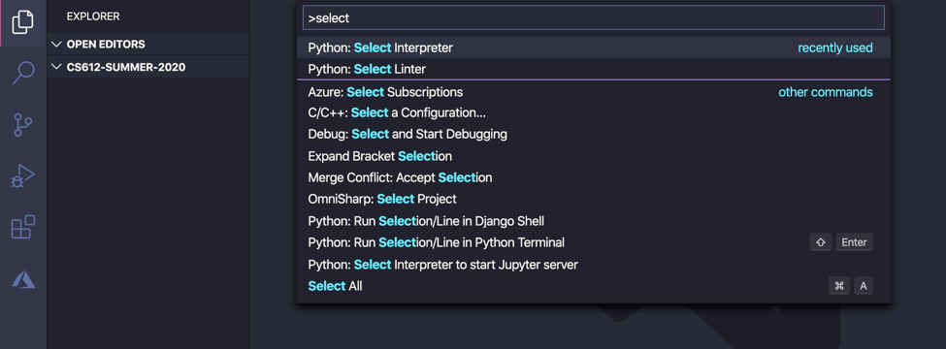

- Choose any Python version you would like to use. (in this case, version 3.8.3 is used)
Once the appropriate environment is activated, you can create and open a Jupyter Notebook, connect to a remote Jupyter server for running code cells, and export a Jupyter Notebook as a Python files.

- Press Ctrl+Shift+P to select a command palette again, then type “create” to bring up Python: Create New Blank Jupyter Notebook and select it from the dropdown. You will see similar screen like the image below.
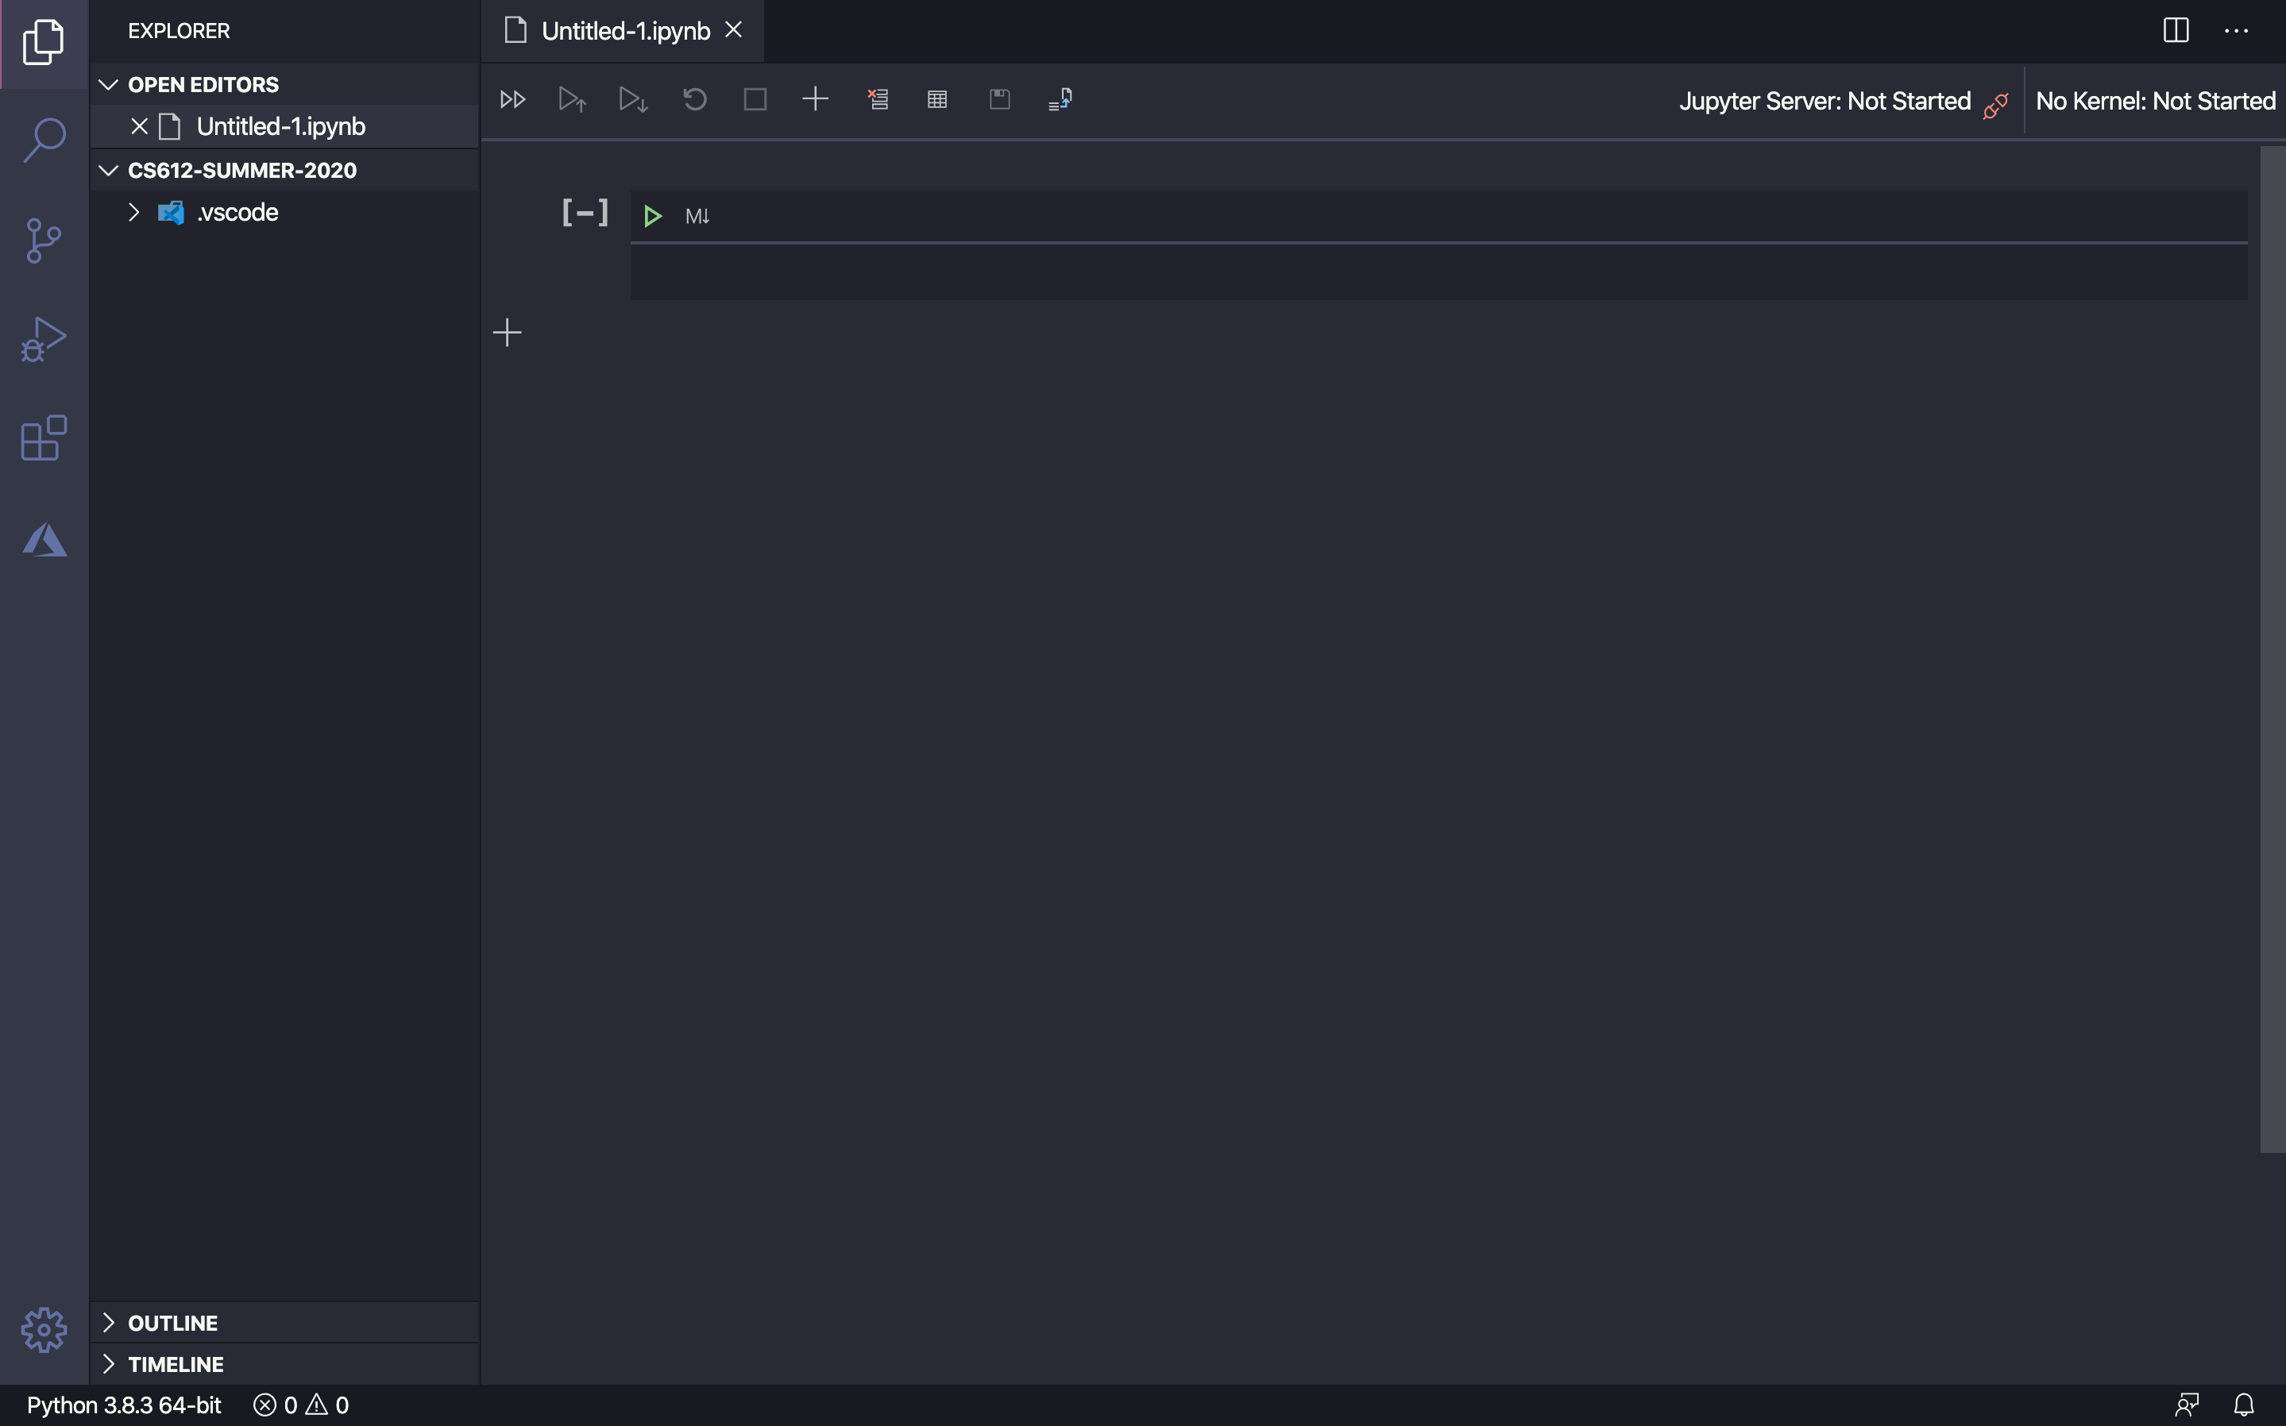

- Type print(‘hello’) into the Jupyter like the following
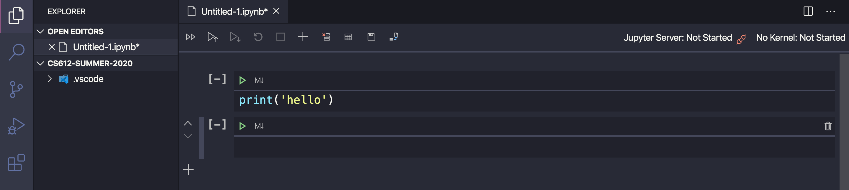

- Click run button and you will get an error says; click install.
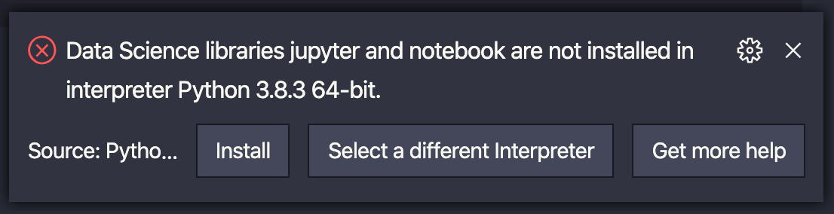

- if you see another error saying "Data Science library ipykernel is not installed. Install?", select "Yes" prompt.

- Restart VS Code by pressing using command palette, then type in “reload” to select Reload Window

- Try Step 4 again to see if jupyter was installed correctly. You should see that Jupyter Server has been connected like the screenshot below.
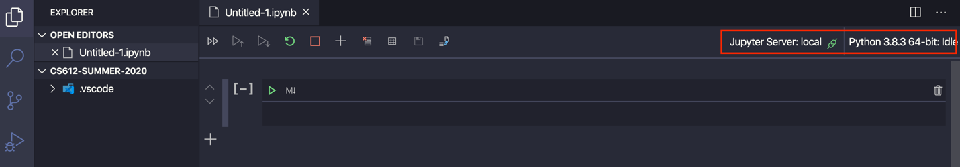

- Type the following in the code cell and hit green run button, it should print out the message just below the code cells.
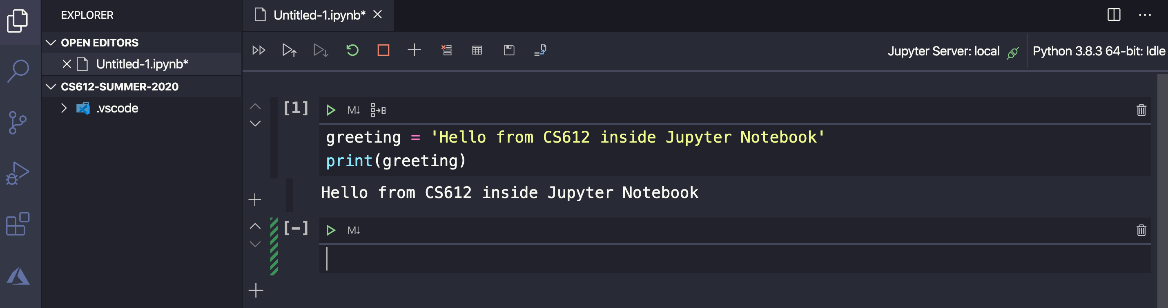

- Now, save it with the name “hello_jupyter.ipynb” under new folder name “Module 6” (for example: CS506/Module 6).
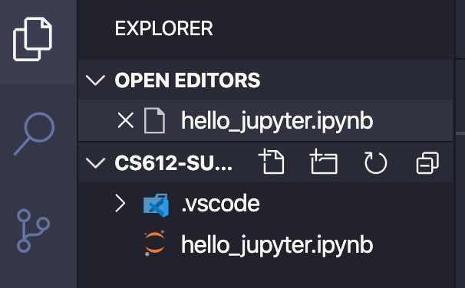
Notice the file you saved will have an extension *.ipynb

Pip
You can also install Jupyter using pip by typing the following commands in terminal:

- python -m pip install --upgrade pip
- python -m pip install jupyter
- Restart VS Code
- Pick the Python environment you did the pip install in
- Then, create a Jupyter Notebook

Tips and Tricks

- Use the command palette: Cmd + Shift + P (Ctrl + Shift + P on Windows)
- To move from edit mode to command mode, press the ESC key. To move from command mode to edit mode, press the Enter key.
- In command mode, press A to add cell above, B add cell below.
- Select a cell, up/down arrow keys
- Run code cell:
- Ctrl+Enter runs the currently selected cell.
- Shift+Enter runs the currently selected cell and inserts a new cell immediately below (focus moves to new cell).
- Alt+Enter runs the currently selected cell and inserts a new cell immediately below (focus remains on current cell).
- Delete a cell, press dd while in command mode.
- Switching between Markdown and code cell, M and Y respectively.
- Enable line number, press L while in command mode.

